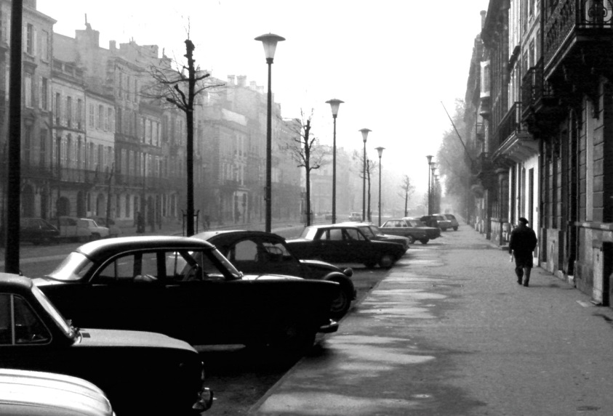

Photo Credit: John Fyfe

**Call for entries: International Photography Competition**

FMoPA accepting submissions through April 13

TAMPA, Fla. –The Florida Museum of Photographic Arts (FMoPA) is now accepting submissions for its 8th annual “International Photography Competition.”

Photographers from all over the world are invited to submit their work. All styles and levels of experience are welcome. Winners will be selected by a jury and announced on May 4. The winning selections will be printed and framed by FMoPA and exhibited in the Community Gallery from June 1-Aug. 17. There will be a formal opening reception from 5-7p.m. June 22 at the museum.

This year’s categories include: People/Portraits, Places/Landscape/Drone, Nature/Science/Animals, Documentation/Social and Political Photojournalism, Still Life, Abstract Photography and Conceptual Photography. Each category will have first, second and third place winners. First-place winners will receive $100-cash prizes. One submission will be awarded Best in Competition over all seven categories and receive a $1,000 prize. Finally, one submission will be awarded People’s Choice and is decided by public votes on the competition website.

Images will be judged on originality, technical excellence, composition, overall impact and artistic merit.

Entries must be submitted online at <http://mulabula.com/splash/fmopa.html>. All entries must be received by 5 p.m. on April 13. Non-refundable entry fees are $10. Multiple submissions are permitted.

For additional information, visit the competition website <http://mulabula.com/splash/fmopa.html>

Creative Loafing is the media sponsor for the 2018 International Photography Competition.

**About FMoPA:** The Florida Museum of Photographic Arts is a museum dedicated to exhibiting important photographic art as central to contemporary life and culture. FMoPA collects preserves and exhibits historic and contemporary works by nationally and internationally known photographic artists. FMoPA also enriches the community by operating outreach programs for children and adults and by offering an extensive array of photography classes.

The Florida Museum of Photographic Arts is one of fewer than 10 museums in the United States dedicated exclusively to photography and one of two such museums in the state of Florida.

**CONTACT:** [Zora@fmopa.org](mailto:Zora@fmopa.org)

Florida Museum of Photographic Arts

400 North Ashley, Cube 200

Tampa, FL 33602

(813) 221-2222 | www.fmopa.org

Monday–Thursday: 11 a.m.–6 p.m.

Friday: 11 a.m.–7 p.m.

Saturday–Sunday: Noon–5 p.m.

(Docent tours every Sunday at 2 p.m.)