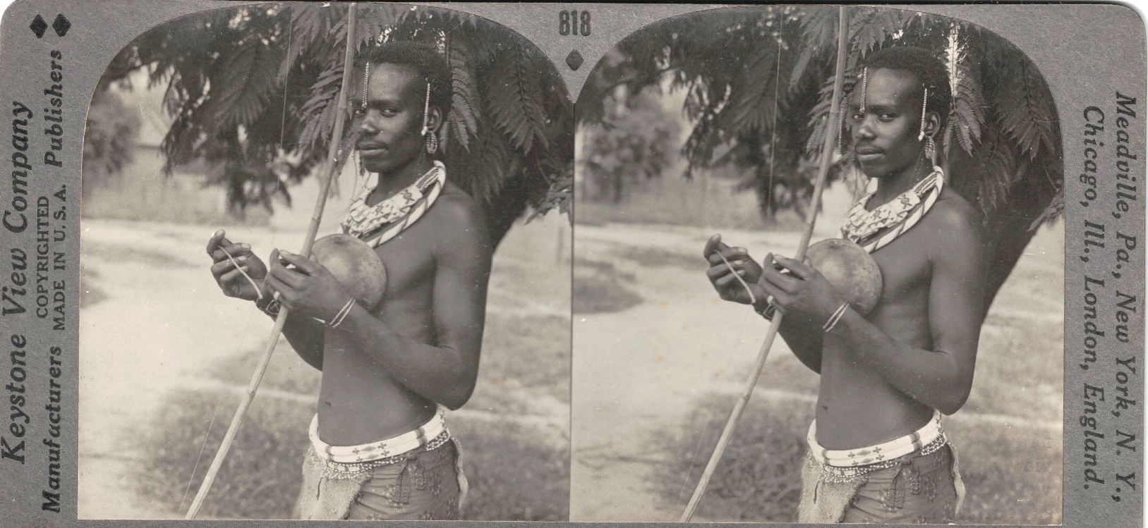

Call for Papers
Sessions on the History of Stereoscopic Photography IV
August 4, 2023
The National Stereoscopic Association’s 3D-Con
The Hyatt Regency Buffalo Hotel, Buffalo, New York
July 31-August 7, 2023

The National Stereoscopic Association is pleased to announce its fourth annual "Sessions on the History of Stereoscopic Photography" at the 49th 3D-Con in Buffalo, New York. Presentations are welcome on any aspect of stereo-media from the inception of stereoscopic photography to immersive stereo media. We project stereoscopically on the 3D-Con's big screen, and our growing community of international scholars represent diverse research from the nineteenth to the twenty-first century. All stereoscopic photography subjects from the historical to the contemporary are invited.
Please send an abstract of 500-600 words and a biography of 250-300 words and contact
information by May 8, 2023.

https://3d-con.com/history.php

Notification of acceptance by May 29, 2023. Digital images will be expected by July 5, 2023.

