and
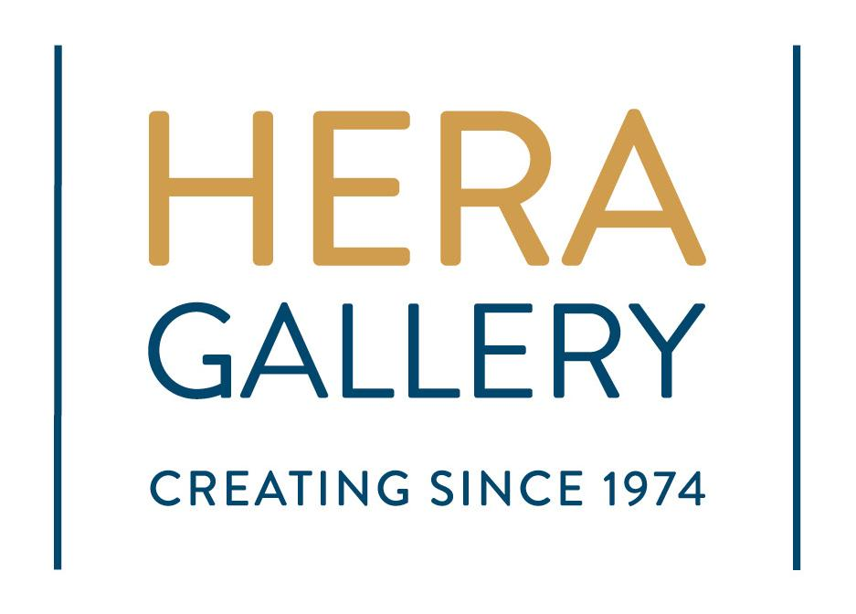
are pleased to present…

“Just B”

Background: Bee In Motion is a nonprofit mobile, music and movement therapy workshop that facilitates self-expression and nonverbal communications with clients of all levels of ability, social fluency, and communication. In conjunction with a licensed Occupational Therapist, Mr. Dennis Harvey, president and founder of Bee In Motion, has developed a repertoire of movement exercises that stimulate changes in brain chemistry and effect positive alterations in emotions, physical functioning, and behaviors. Mr. Harvey strives to create an atmosphere of mutual respect and learning between people of all abilities. He has created Bee in Motion as a vehicle to encourage self-discovery in others and to promote the expression of inner feelings through music and movement.

Hera Gallery, the fifth oldest Feminist art cooperative in America, promotes a professional artistic presence that enhances the community through education, collaboration and involvement. Our vision is to erase all barriers to artists, broaden public interest in artistic expression, and enhance our community’s exposure to local, regional and nationally recognized artists.

Concept: Bee In Motion with the help of Hera Gallery is seeking artwork to be part of Pop-up art exhibition and fundraising auction to help bring awareness to Mr. Harvey’s workshop as well as help him continue his mission.
Artwork should be centered around “B” but that could mean bumble bee, the letter “B”, or much like the name of Mr. Harvey’s foundation, a “state of being”; being happy, being sad, being still, or being in motion. “Be” creative, “Be” inspired. Interpret however you wish.

Application and work
Drop off Deadline: Friday, December 15th, 2017.

Pop-up Exhibition: January 3rd - January 13th
Opening Reception: Saturday, January 6th, 6-8pm

Auction Dates: Sunday, January 21, 2018

Entry Fee: No Entry Fee

Eligibility: Open to works of any medium excluding performance and installation. 3D limited to 50 lbs and must be no larger than 2”x2”x2”. 2D work must be able to fit through a standard doorway.

Guidelines: Work should be submitted via email to awmercier@gmail.com with “Just B” in the subject line. The body should contain the title, medium, dimension and value of artwork.

Due to room restrictions, only the first 100 submissions will be accepted. Furthermore, any artwork not sold during the auction will be kept by Bee in Motion to be used in later auctions and events.
Files should contain jpeg images of work; an image list that contains artist name, address, phone numbers, email, title of work, year completed, medium, dimension (h x w x d) and price.

Jpegs must be 300 dpi and maximum 1024 pixels on the longest side. Video Submissions MUST be in either low resolution or H.264 format.

Image Name: Lastname_TitleofWork
ex: Smith_Untitled.jpg

Notification Of Acceptance: Artists will be notified of acceptance within 48 hours.

Artwork Delivery: Upon acceptance, work should be shipped to Hera Gallery
Attn: Just B
Hera Gallery
10 High Street
Wakefield, RI 02789

Artist is responsible for all shipping costs and shipping containers.

Insurance: Although the utmost care will be taken in handling your work, Bee in Motion and Hera Gallery assumes no responsibility for damage, loss, or theft. Artists are responsible for their own insurance.

Photography/Publicity: Bee In Motion and Hera Gallery reserves the right to photograph work for publicity. By entering this exhibition, you agree to the use of your name, likeness, certain personal information, and artwork in any publicity material or documentation developed for the exhibition.

Digital Submission to:
awmercier@gmail.com
Subject Title: Just B
Please allow 48 HOURS for processing.

Contact
Adrien Mercier
Email: awmercier@gmail.com
Websites: www.beeinmotionri.com
www.heragallery.org

